(a) Measures / scales for motivations for long distance hiking

**Article Name: Motivation and metal wellbeing of long-distance hikers**

* **Demographics**
* **Anthropometry** (BMI from self-reported height and weight according to Adolphe Quetelet formula)
* **Physical activity** (how long they have been hiking and how many kms did they perform in the last 12 months)
* **Well-being** (WHO well-being index to measure subjective psychological well-being)-5 items scored from 5(all the time) to 0(none of the time)
* **Emotional Profile** (DASS-21 measured distress along depression and anxiety)- 4 point scale
* **Loneliness** (UCLA 3-item loneliness scale)- The scale uses three response categories: hardly ever (1), some of the time (2) and often (3). Scores are summed and higher scores indicate more loneliness. There is a cut-off point of 6 and above indicating loneliness of individuals. Internal consistency of the scale in our sample was (α ¼ 0.849).
* **Overall life satisfaction** (evaluated using Cantril’s Self Anchoring Ladder of satisfaction-10 step ladder)
* **Perceived Health Status** (visual analogue score (0-100)- higher scores indicate better health)
* **Exercise Addiction** (Exercise Dependence Scale-Revised on a 6 point Likert scale ranging from 1 (never) to 6 (always), The scale allows both interval data and nominal categorization. The scale is based on DSM-IV criteria for substance dependence: tolerance, withdrawal ef-fects, intention, lack of control, reduction in other activities, time, and continuance. Hikers scoring 5 or 6 out of the seven DSM-IV criteria were classiﬁed as at risk for EA while those scoring in the range of 3–4 were classiﬁed as non-dependent symptomatic, and scores of 1
* **Motivation** (face to face 15-20 mins interview that were audio recorded)

**Article Name: Why do people hike? Hiking the Israel national trail**

* Motivations
  + Love of nature
  + Physical and athletic motivation
  + Self-reflection, reflexivity and self-development
  + Serious leisure
  + Spiritual and cultural motivations
  + Religious motivations
  + Social “Communitas”
  + Hiking as manifestation of Nation and state building
  + Love of country
  + Ideology

(b) Measures/scales for digital technology use (before, during, after hikes)

**Article Name: The places of our lives; visiting patterns and automatic labeling from longitudnal smartphone data**

* **Mobility data**
* **Application usage**
  + usage statistics of some frequently used apps such as e-mail, multimedia player, web browser, voice call, SMS, and so on.
* **Bluetooth** 
  + We compute BT features using the number of distinct BT devices observed during a visit
* **Wifi** 
  + Similarly, to Bluetooth data, we used the number of distinct WiFi access points to characterize the place to define WiFi features

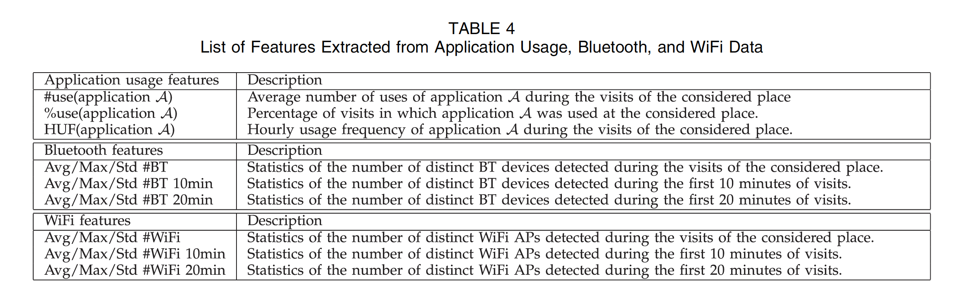**Article Name: Past, Present and Future of Tourist Tracking**

In this article, three techniques were used to track tourists; logger, app and a survey (experimental approach)

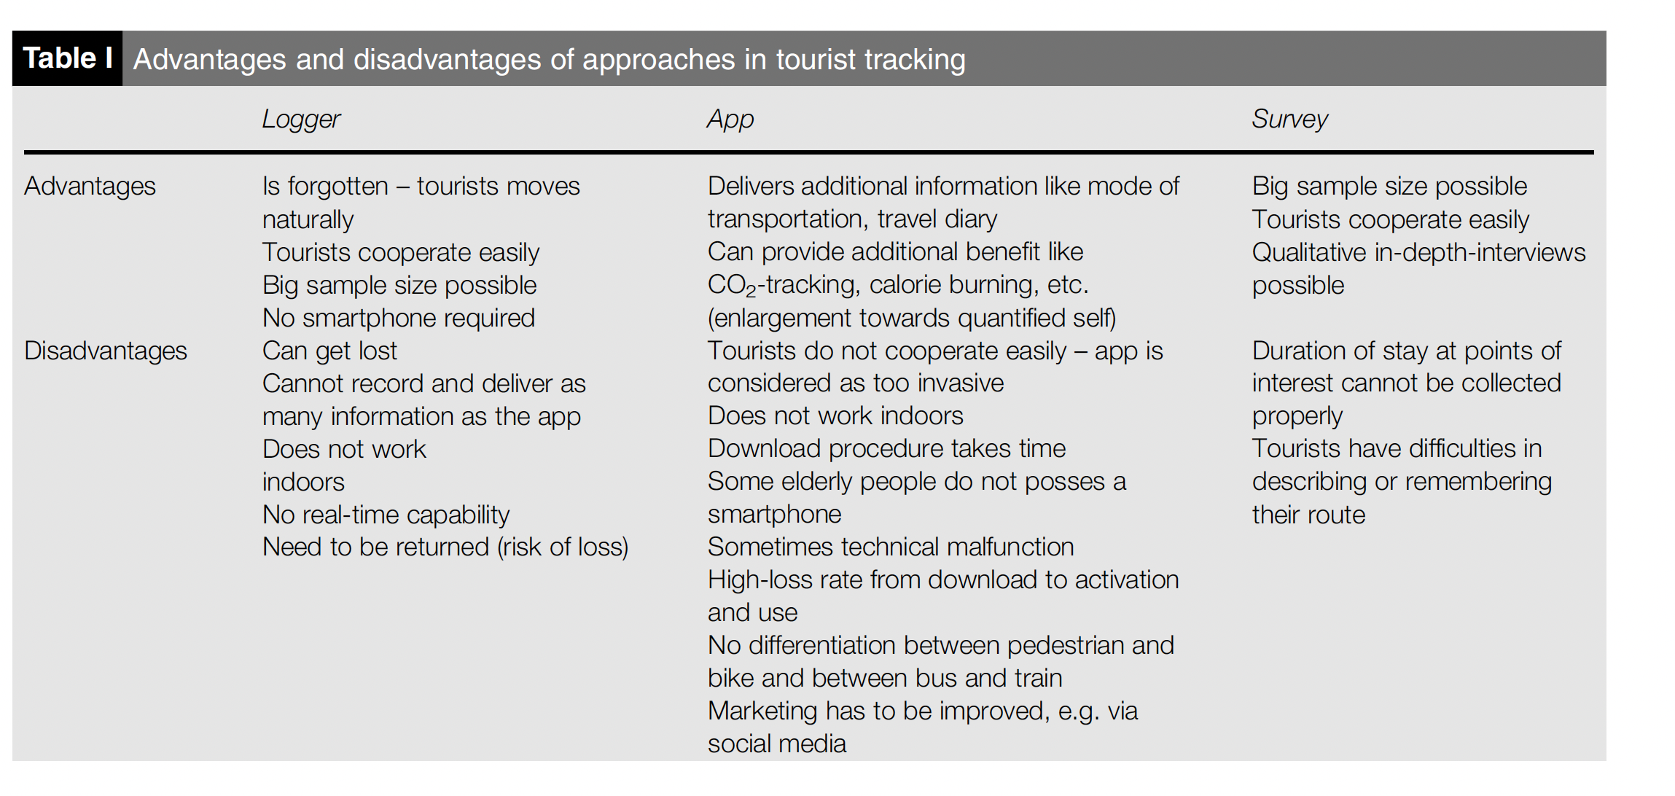

**Article Name: User requirements for location-based services to support hiking activity**

**From the book: Location based services and telecatography**

Types of digital technology apps a hiker would need

• Planning a hike

• Additional information on the area

• ‘I am here’ services

• Location of other hikers

• Changing conditions

• Emergency situations

• Saving experiences

• Sharing experiences

• Integrated and adaptive services.

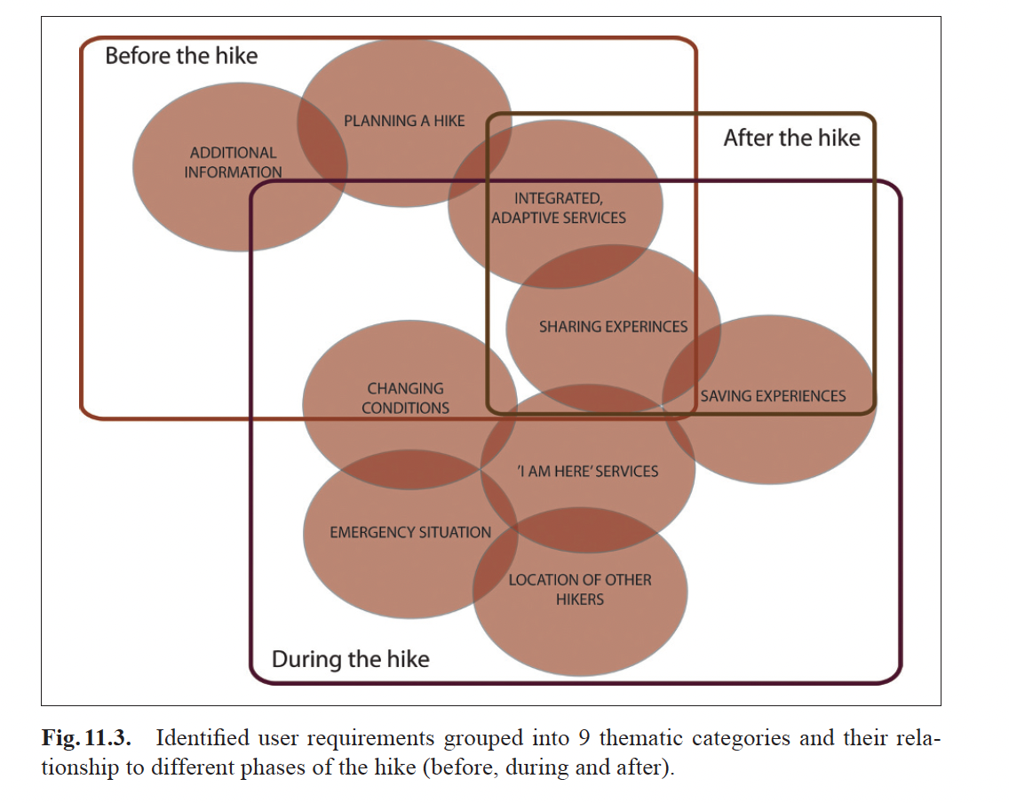

**Article Name: How People Really Use the Mobile Web**

Motivations for mobile use

* Awareness
* Diversion
* Time management
* Social connection
* Curiosity
* Social avoidance

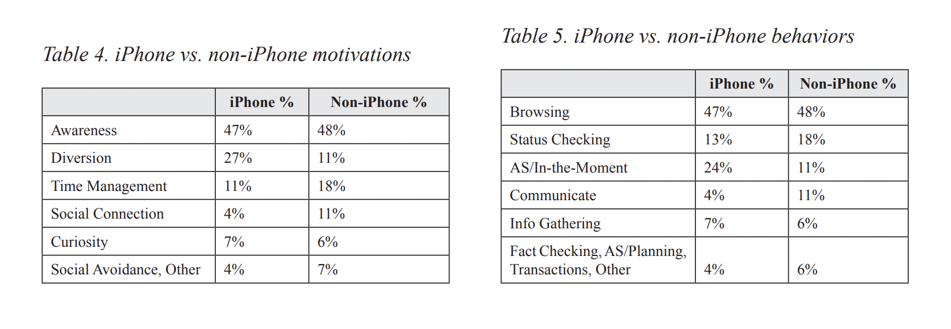

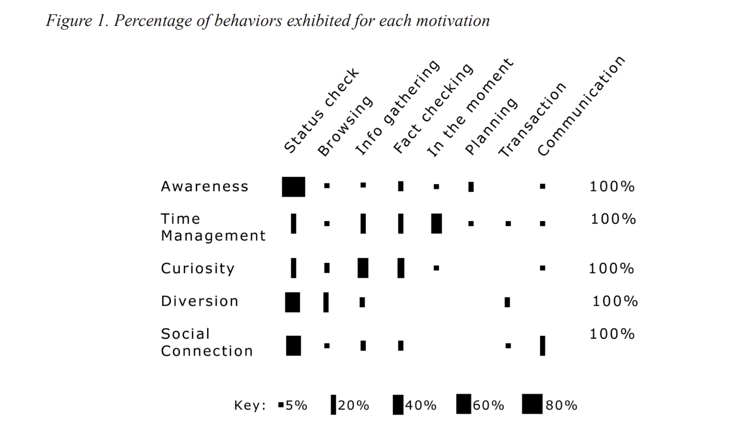

(c) Measures of social experiences on the trail

**Article Name: Why do people hike? Hiking the Israel national trail**

* Experience and Behavior
  + Hiking as a discipline and technique
  + Hiking as End of Means
  + Multidimensional Structure and Experience
  + Body and soul
  + Becoming one with the land
  + Identification with the land
  + Hiking as affiliation to the land
* Achievements to hiking
  + Hiking itself
  + Mental and spiritual motivations
  + Happiness, satisfaction and enjoyment
  + Physical, health and body
  + Sociability
  + Knowing the land
* Obstacles to hiking
  + Physical difficulties
  + Mental difficulties
  + Health difficulties
  + Social constraints

**Article Name: Ways of walking-developing a pedestrian typology for personalized mobile infromation systems p.79**

**From the book: Location based services and telecatography**

Using two types of data; heuristic and deductive to determine pedestrian typology

* Pedestrian Speed (from tracking)
* Stops (from tracking)
* Lifestyle (from questionnaire)
* Social status (from questionnaire)